Communications Handbook for Faculty
Department of English
(update: March 7, 2024)

Table of Contents
Mission and Duties
Style Guide
Content Responsibilities & Requirements
Image Guidelines
Social Media Strategy
Content and Permissions
How to Write Spotlights

Mission and Duties
The Communications Coordinator reports to the Department of English Chair and manages all official department websites, including social media accounts. Specifically, the Communications Coordinator oversees and updates the format and content of the department’s main website to ensure accessibility and usability.

Duties of Communications Coordinator
- Manage the main department website in a way that produces a high-quality user experience.
- Promote the department and its programs, including publicizing departmental events, individual achievements, and other updates.
- Ensure the department’s communications align productively with the College’s communications, requests, and goals.
- Respond to faculty requests promptly.
- Train graduate assistants in web and social media management as they are assigned to this position (typically two GAs per semester).

Duties of Communications Graduate Assistants
- Manage and update the department’s main website to ensure a high-quality experience for all users.
- Curate content on all official department websites, including social media accounts.
- Facilitate internal forms of communication (e.g., email, newsletters, Sharepoint).
- Publicize departmental events, individual achievements, and other updates
- Deal with requests from faculty promptly.
- Design and engage in special projects in consultation with the Communications Coordinator.

Content Responsibilities & Requirements (ECU Link)
The following are the responsibilities and requirements for which you, an owner of content available via a website on the ecu.edu domain, are responsible. These responsibilities include compliance with federal and state laws and applicable ECU policies and the items in the lists below:

Website owners must ensure that all content is:
- Accurate and up-to-date.
- Supports the purpose of the website.
- Accessible on all types of devices and follows accessibility guidelines.
- Follows sensitive data guidelines and is approved for posting by the appropriate data owner.

Additionally, website owners must also ensure that:
- Media content and files recorded by ECU constituents follow the Media Release Consent Guidelines.
- Required approvals for copyrighted material are obtained, and if applicable, that access is limited. For more information, visit ECU’s copyright guidelines.
- Public video is closed captioned.

Image Guidelines
- For Department Website
  - To comply with the ECU WordPress Template, all images for the front page of the department website need to be 2185x725 pixels. However, faculty need not remember these dimensions when taking photos. To achieve a usable image, take the picture in landscape mode with the action occurring side to side. A good reminder is to imagine how the photo would appear on a cinema screen. Here is a recent photo to serve as an example:

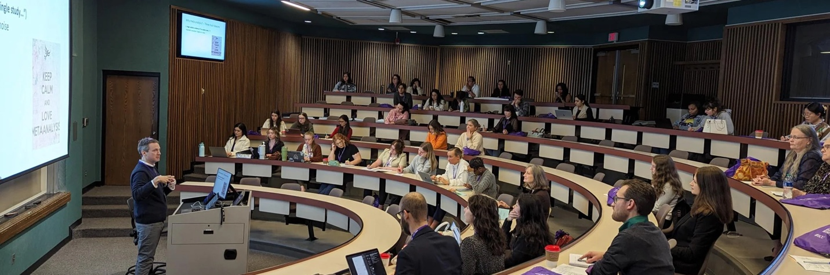

- For Social Media
  - The Communications Team can use photos of all sizes for the department’s social media outlets (Facebook, Twitter, and Instagram).
  - However, Instagram images are vertical.
  - When taking photos of your event:
    - Set your camera to its highest resolution.
    - Get as close to the speaker or action as possible.
    - Take multiple shots.
  - Please do not use digital zoom, as the images produced tend to be grainy and pixelated.
  - Unfortunately, ECU photographers no longer have a site to request their involvement at department functions.

Style Guide
Unless otherwise established, use Associated Press Style (the standard style for reporting information to the public) in content that will be publicly available. (Learn more about AP style here: https://owl.english.purdue.edu/owl/resource/735/02/)

Exceptions include:
- When referring to a person who holds a Ph.D., refer to that person as “Dr.” throughout the piece unless it would be confusing to do so.
- When constructing a list of references, use APA as the default style. (Because this department is interdisciplinary, other styles may sometimes be appropriate.)

ECU authorizes using all logos, which they call “visual identifiers.” We have several approved visual identifiers for department use, and they can be found in the “VisualIDs” folder in our Google Drive space.

Social Media Strategy
Goals and objectives
Our social media goals and objectives are:
- Promote the English department to prospective students, alums, administrators
- Get students involved with department events
- Demonstrate engagement with the local community.

Content and Permissions
The department's Facebook page, Twitter profile, and Instagram page host many images of department people and events available for use as stock photos. These include images of the logos/headers for department publications. Photos already posted publicly may be used for any not-for-profit work related to department communications.

When taking photos, secure written permission from the subject(s) if the photos are taken in a non-public venue (such as a classroom). The following language may be used if it is helpful.

I hereby consent to the photographing/videotaping of myself and the recording of my voice and the use of these photographs and/or recordings singularly or in conjunction with other photographs and/or recordings for advertising, publicity, or other business purposes by East Carolina University in domestic and foreign markets. I understand that the term "photograph" as used herein encompasses both still photographs and motion picture footage. I hereby release East Carolina University and any of its associated or affiliated companies, their directors, officers, agents, employees and customers, and appointed advertising agencies, their directors, officers, agents and employees from all claims of every kind on account of such use.

Print Name: ___________________________
Signature: ___________________________
Date: ________________________

