Intro to Literature
ENGL 1000, 601 (DE) SS1 2024, asynchronous. Dr. Helena Feder
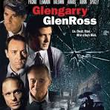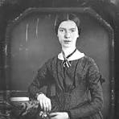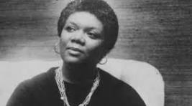
In this introductory course, we will consider many questions: What does it mean to “appreciate literature”? And what counts as “literature”? Love poetry? Comic fiction? Horror fiction? Science Fiction? Are there differences between art and entertainment? In this introductory, asynchronous ONLINE course we will read poems, short fiction (GREAT stories, including realism and fantasy), and one play during SSI. The subtitle of this course—network animals—makes it clear that this is a course that studies literature, written for adults, in the context of complex social worlds.
Texts
Glengarry Glen Ross, by David Mamet (Grove Press)
Norton Anthology of Modern Poetry vol.1 (Norton, third edition)

